

UCSC ARC CPOL Antenna and DTMF Control

Winter 2015 Report

03/20/2015

**Table of Contents:**

Team Members……………………………………………………………………………….3

Abstract……………………………………………………………………………………….4

Introduction………………………………………………………………………….………...4

Problem Statement/Motivation..……………………………………………………..4

Approach……………………………………………………………………………..4

Descriptions…………………………………………………………………………………...5

System Overview…………………………………………………...………………....5

Antenna………………………………………………………..……………………..7

Design………………………………………………….……………………..7

Implementation………………………………………..……………………..8

DTMF Controller …………………………………………………….…………..…...11

Overview……………………………………………………..……………...11

Research/System Requirements…………………………………………..11

Design (Hardware)…………………………………………………………12  
Design (Software)...........………………………………………….……….....14

Challenges/Alterations………………………………….………...…….….15

Antenna Switching System……………………………………...………...……...….15

Overview………………………………………………...…..……..………...15

System Requirements………………………….………………………..….16

Design………………………………………………………….………….....16

Linking Interface…………………………………………...…….………………...…19

Overview………………………………………..……….…………………...19

Research/System ………..…………………………...……...……………....19

Requirements………………………..………………...…….………………19

Design…………………………………...……………….....………………...19

Implementation…………………..……………………...…………………...20

Design Challenges/Alterations………....…………………………………...21

Echolink Node ……………………………………………..………………………....22

Overview………………………………………..………………………....…22

Research/System Requirements…………………………………………...22

Design………………………………………………………..………………22

Implementation…………………………………..…………………………..22

Design Challenges/Alterations…………..………………………………….23

Allstar Link Node …………………………………………………….……………….23

Overview……………………………………………………..…………….....23

Research/System Requirements………………..…………………………..23

Design……………………………………………………………...……….....23

Implementation………………………………………………....…………….24

Design Challenges/Alterations…………………………………..…………..24

Accomplishments………………………………………...…………………………....24

Future Work……………………………………………………………....…………...25

**Team Members:**

**Tim Grat Bodkin**  *Undergraduate Computer Engineer – University of California Santa Cruz*  *Team Lead*

Tim is a senior majoring in Computer Engineering, with a focus of digital hardware design, with a minor focus in Electrical Engineering. Tim's experience includes software, and embedded system design, analog electronics, PCB design, hardware design, and working with digital audio, and audio electronics. Interests mainly reside in audio and DSP applications.

**Chris Tatosian**  *Undergraduate Electrical Engineer – University of California Santa Cruz* *Assistant Team Lead*

Chris is a senior studying Electrical Engineering. Has an undergraduate focus in analog electronic design with experience in analog RF and Microwave hardware design, PCB design and antenna theory. Interests in physics (EM/quantum), audio electronics, RF and IC design as well as materials science. Chris is currently working as an undergraduate researcher in Nobuhiko Kobayashi’s materials science lab NECTAR (Nanostructured Energy Conversion Technology and Research) characterizing nanomaterials.

**Luis Ceja**   *Undergraduate Electrical Engineer - University of California Santa Cruz*

Senior studying Electrical Engineering with a focus in optics, and electronics with experience in PCB design, software design for embedded systems, and hardware design. Interests mainly include hardware applications and electronics.

**Kevin Helms**  *Undergraduate Electrical Engineer and Computer Engineer - University of California Santa Cruz*

Kevin is a senior undergraduate student double majoring in both Electrical Engineering, with a focus in Electronics and Optics, and Computer Engineering, with a focus in Digital Hardware. Kevin has experience with power engineering, PCB design, embedded system design, and analog electronic design. His academic interests include RF design, communication systems, and electromagnetic waves.

**Abstract:**

Prototypes for an antenna switching circuit and DTMF control circuit were constructed. A repeater audio linking interface design was completed along with a layout in software. The Echolink and All-Star link were configured and implemented. An antenna prototype was modeled and constructed. The antenna measurements were confirmed to agree with simulation.

**I. Introduction:**

**Problem Statement/Motivation:**

UC Santa Cruz currently utilizes a repeater which AC6P and K3RRY designed and built for radio communications. The repeater listens for low power signals, beginning with PL tones, at 144.710 MHz and immediately rebroadcasts, or ‘repeats,’ them at much higher power on a 145.310 MHz in order to increase the range of wireless communication. Ideally, for reliable communication a repeater antenna would be at the top of a tall building in the line of sight of those it is trying to communicate with. The location of UCSC and the surrounding geography present a problem with wireless communication and due to the mountainous terrain, some coverage areas are shadowed by hills and are subject to multipath interference.

We currently have a 7/8 wave vertically polarized antenna on the roof of Baskin Engineering, vertical polarization meaning the electric field vectors of the propagating wave are perpendicular to the earth. Vertically polarized waves have a high likelihood of being degraded, this is due to refraction and absorption. Different materials absorb and refract waves at different angles depending on how the wave is polarized. By the time the traveling wave reaches our repeater it may be tilted as it travels over the earth or bounced off objects or hills. By super position this may result in a horizontally polarized wavefront which would cause a loss of 20 dB or more in received power, or multipath interference due to waves being out of phase and cancelling out. Our goal is to create an antenna which radiates with circular polarization. This mitigates the polarization mismatch and results in only 3 dB of loss regardless of how the linear antennas are oriented and is much lower probability of being degraded due to absorption and refraction compared to linearly polarized waves.

**Approach:**.

Our approach is to design, characterize, and implement a circularly polarized antenna to increase the UCSC AC6P Repeater range and to mitigate multipath interference in troublesome coverage areas areas. The antenna will be interfaced with the repeater via DTMF protocol, allowing for smooth switching between the current linearly polarized antenna and the circularly polarized antenna wirelessly, from a portable radio. Echolink and All-Star Link nodes will be integrated into the current system with our DTMF controller, allowing worldwide access to our repeater.

**II. Descriptions:**

**System Overview:**

By reducing multipath interference, the circularly polarized antenna design will increase the local reach, and dependability of the UCSC amateur radio repeater. Additionally, two separate RoIP nodes will be implemented which will interface with the repeater, thus providing world wide connectivity with the amateur radio community. RoIP, which stands for “Radio over Internet Protocol” is similar to VoIP, and in fact uses many of the same protocols as services such as skype. By implementing two nodes which use 2 different protocols this would allow the repeater to communicate with people on multiple networks, namely, Echolink, and Allstar Link.

Each RoIP node requires its own linux based single board computer, as well as a path for audio, and control signals, to and from the repeater. Since there will be multiple devices in a single system with a need to meet these requirements, a linking interface has been designed, which directly facilitates the interaction of the audio and control signals to and from the repeater. This linking interface is designed with embedded control logic to ensure that only a single RoIP node can transmit to the repeater at any given time.

Once fully integrated, the system, from a high level perspective will function such that a person in the field will have the ability to communicate with the UCSC repeater through their handheld, mobile, or stationary transceiver. Both the antenna switching circuit, and the   
RoIP nodes are designed to be controlled wirelessly via DTMF protocol which is sent from the keypad of the user’s transceiver. Using predetermined DTMF sequences, the user will have the ability to choose which antenna they would like to use, as well as activate, and operate the RoIP nodes, thus giving them the ability to communicate with other nodes, both amateur radio nodes, as well as non-radio nodes.

As shown in Figure 1, the high level description of the signal path shows that all audio will go from the repeater through the linking interface, where it is then sent through audio codecs to the RoIP nodes. The audio is also sent from the linking interface to to the DTMF decoder present in the antenna switching controller. All of these devices are constantly listening for their respective DTMF sequences before they can be activated.

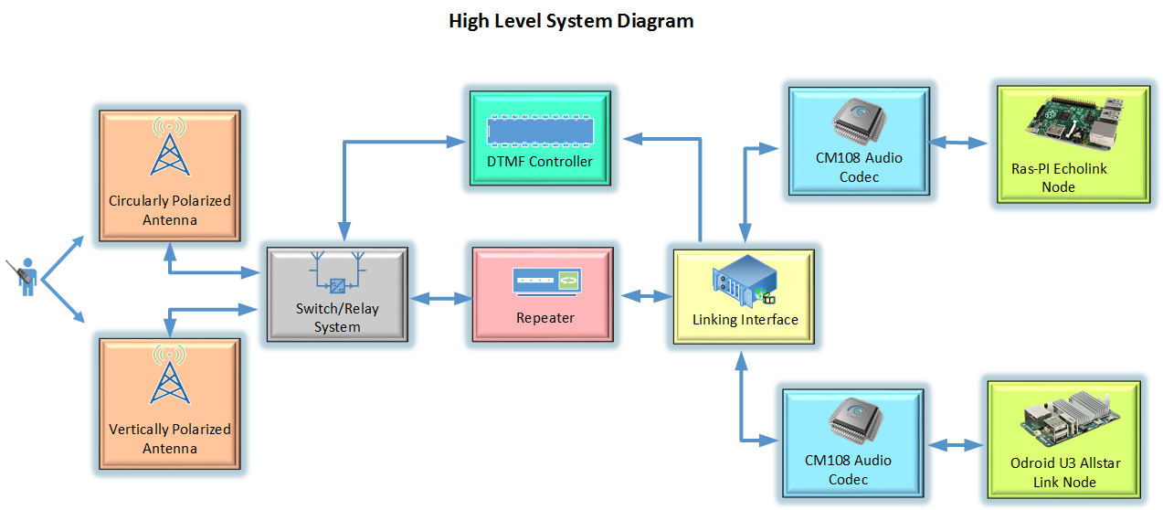

Figure 1: High Level System Diagram

RoIP, which stands for “Radio over Internet Protocol” is similar to VoIP, and in some instances uses existing VoIP protocols. Once a user activates an RoIP node, the user must then key in the number of the node they would like to connect with. Depending on which network is being utilized, the destination node does not necessarily have to be another repeater, or radio. In addition to repeater, and transceiver nodes, the Echolink network for example, allows users to use their mobile phones, and PCs to connect to the network.

Once the user has established a connection with their desired node, all audio from the user is digitized in an audio codec and put into data packets specific to whichever protocol is being utilized. The Allstar Link for example, utilizes the well known VoIP protocol, Asterisk. Both RoIP networks also offer the ability to connect with multiple nodes, in what is known as conferencing. Figure 2 shows a basic path diagram of how RoIP works, as well as its capabilities.

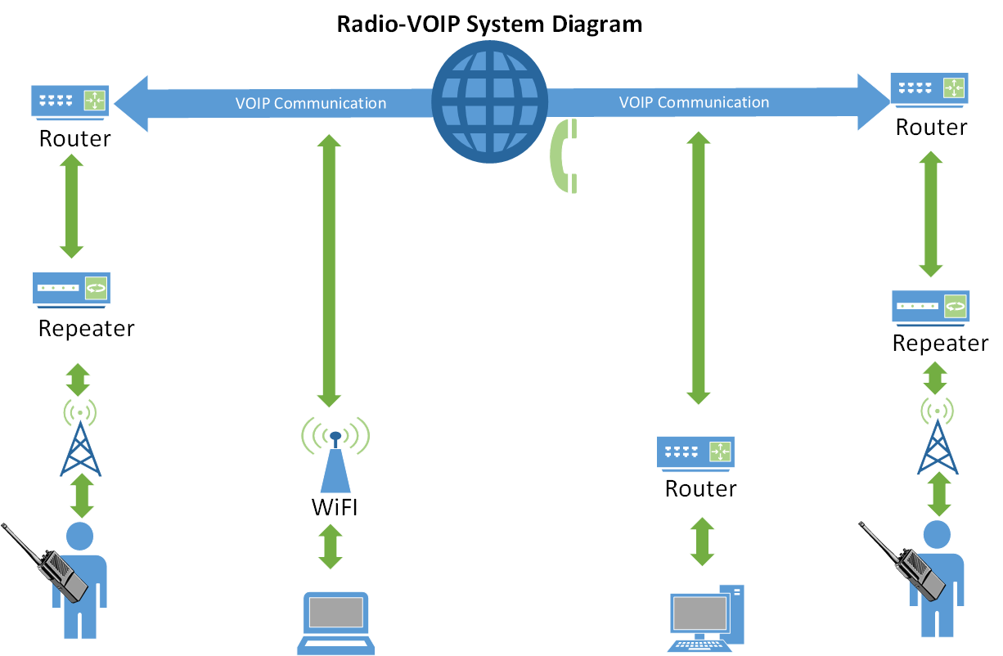

Figure 2: VOIP Communication Diagram

**Antenna:**

**Design:**

The antenna design was based off of work done by WA7X due to the simplicity of the design, and the availability of materials. With the specifications of the design being similar gain as the current antenna, and a high axial ratio, a good starting point was a quarter wave vertical dipole connected to a half wave loop. The design was refined until a maximum gain and high axial ratio was achieved. Modeled in free space, the vertical gain is shown in Figure 3.

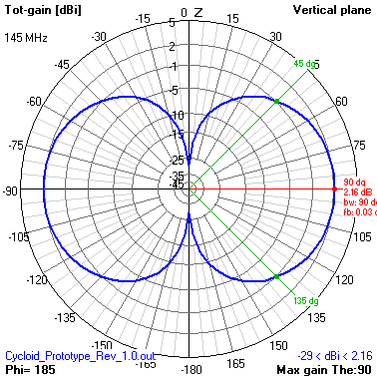

Figure 3: CPol Radiation Pattern

Maximum gain was achieved in the horizontal, a desired result, though it is much less than the current antenna at 2.16 DBi. The axial ratio of this initial design was between .7 and 1.0 as shown in Figure 4.

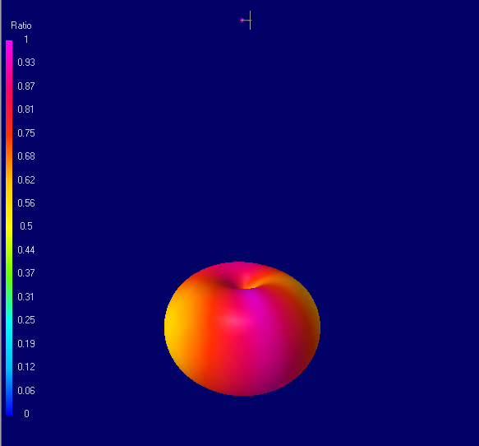

Figure 4: Axial Ratio Model

**Implementation:**

Taking this promising data, a prototype was constructed using ¼” copper pipe. From here, there were design challenges in making the antenna structurally stable as well as taking accurate measurements. The initial measurements seemed inaccurate, and was later confirmed to be due to calibration and the way the antenna was being fed the signal. Since the initial measurements seemed to disagree with simulation, a simple quarter wave dipole was constructed so that more accurate measurements could be made on a simpler antenna. In doing a so a more legitimate, stable, feedpoint was constructed. Upon confirmation with simulation, the dipole was disassembled and the feedpoint was transferred to the CPol antenna. With the CPol antenna completed, accurate measurements of the dimensions were drawn and input to 4NEC2 to have a more accurate model to base results on. The results for the radiation gain, and axial ratio are shown in Figures 5 and 6, respectively. The model was done assuming the antenna was in a medium forest and hills environment as it was the most accurate description of our area.

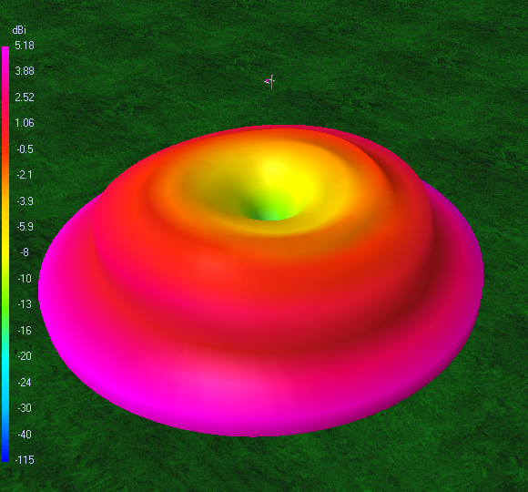

Figure 5: Antenna Model -Gain

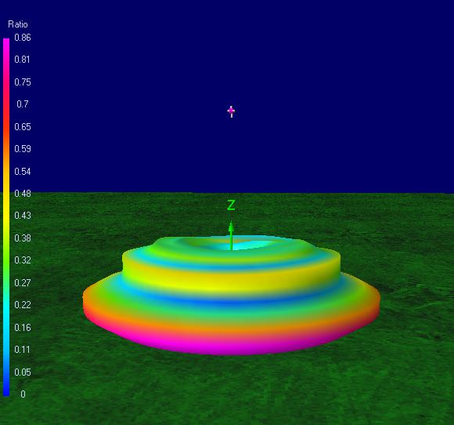

Figure 6: Antenna Model - Axial Ratio

The results show a maximum gain and axial ratio in the horizontal direction, minimizing radiation in the vertical which would was radiated power. The maximum gain, when modeled in similar environments as UCSC, increases to a value similar to the current antenna gain at 5.6 dBi.The CPol antenna was mounted and placed away from people and objects, as to not interfere, and the calibration plane was accurately set to the feedpoint of the antenna. Sweeping frequencies between 135 MHz and 160 MHz, the feed impedance measurements are shown in Figure 7.

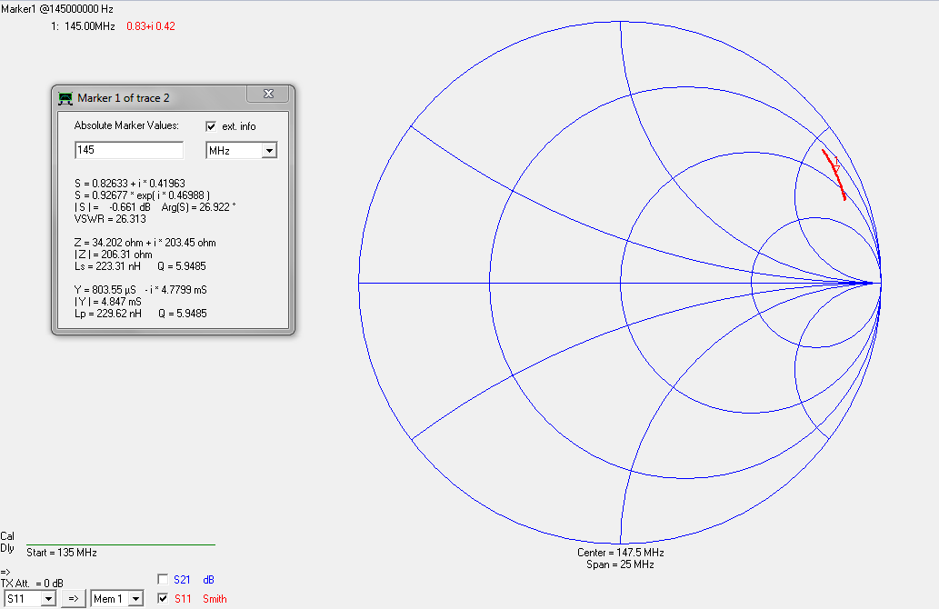

Figure 7. Actual Feedpoint Impedance of CPol Antenna

Comparing this to the results given by the model, shown in Figure 8, we can see that the results agree with simulation and show a successful proof of concept. The radiation resistance is near the exact same values throughout the frequency sweep as the model, with a drop in inductive reactance

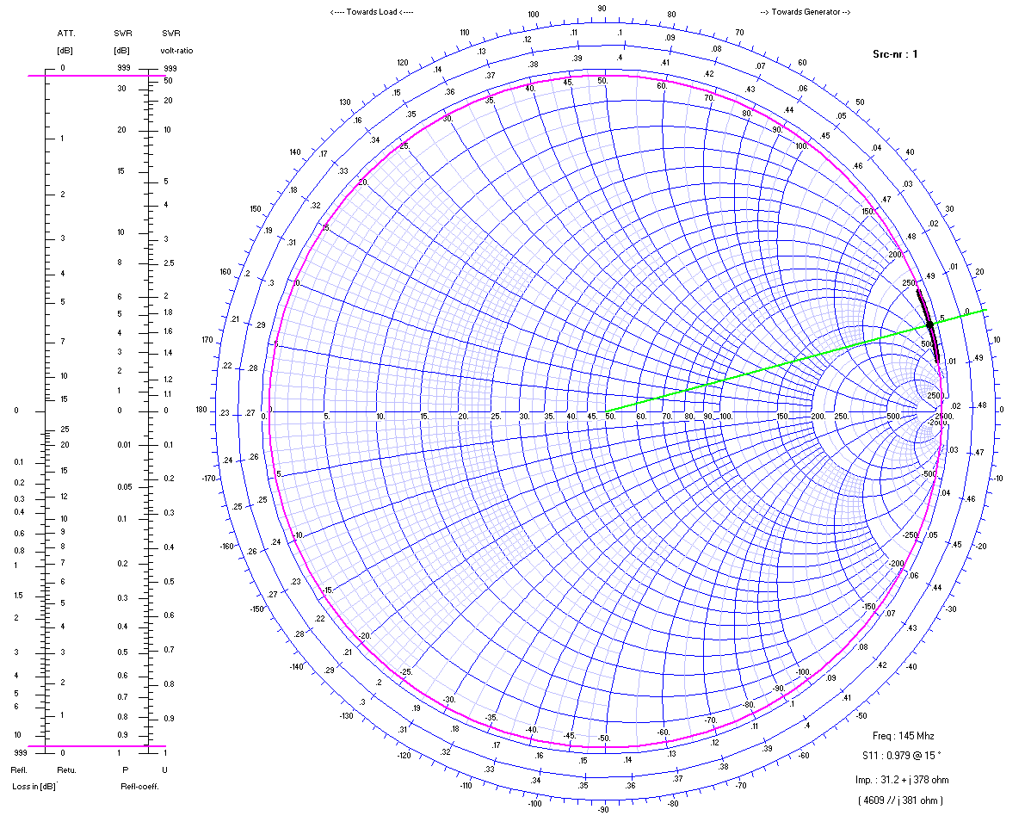

Figure 8: Feed Impedance of CPol in Simulation

**DTMF Controller:**

**Overview:**

The DTMF controller will serve a major purpose in the project: control the switching of antennas from the field. This module is responsible for decoding incoming DTMF sequences, acknowledging a command to switch antennas, and preventing the repeater from transmitting while switching.

**Research/System Requirements:**

The DTMF controller requires the use of a DTMF decoder and a microcontroller to regulate the incoming sequences as well as the antenna switching process. DTMF decoding can be done either through DSP or hardware, but we decided that hardware would be more practical to create.

We decided to use the MT8870 DTMF decoder as well as the Atmega 328 as the microcontroller. The MT8870 takes in audio input and listens for specific DTMF sequences. There may be false positives in the incoming audio stream, so there is an adjustable time constant that sets the minimum duration that a DTMF tone may be to be decoded. It also outputs a 4 bit binary number representing a decoded tone. The output StD goes high when a valid tone is detected. The binary output to the 8870 is a latched, so the value remains the same until the next DTMF tone is detected and decoded.

**Design (Hardware):**

The first DTMF controller design used AND gates to implement pulses instead of the latched binary output of the MT8870. By ANDing the binary outputs from the DTMF decoder, the latched output becomes pulsed.

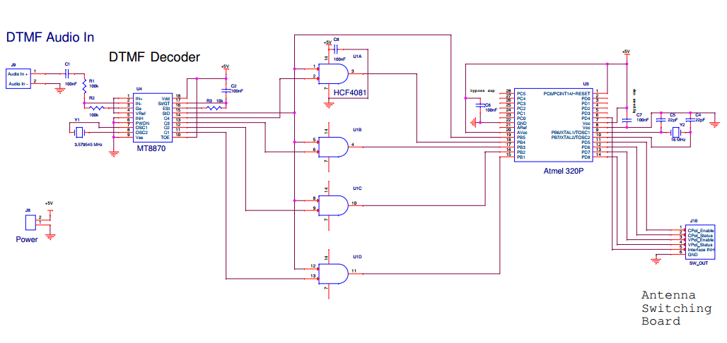

Figure 9: DTMF Controller Schematic

A couple of things were changed from the original DTMF controller. First, the Atmega has an internal oscillator at 8MHz, which leads to a system clock of 1MHz. According the the timing diagram in Figure 10, StD requires a duration of tREC to be set high. Once it is high, it will remain high until the tone disappears and an additional discharge cycle tGTA.

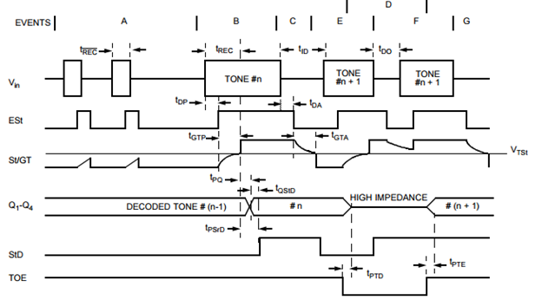

Figure 10:Timing Diagram

The least amount of time St can remain high is then tGTA, which is equal to 22ms. Assuming the dtmf codes are changing as fast as validly possible, the fastest frequency that StD can change is only 45Hz. This assures that the internal system clock for the Atmega is fast enough to read interrupts from the DTMF controller. LCD screen capabilities were added as well to the design for debugging purposes. Figure 11 shows the final pulse design:

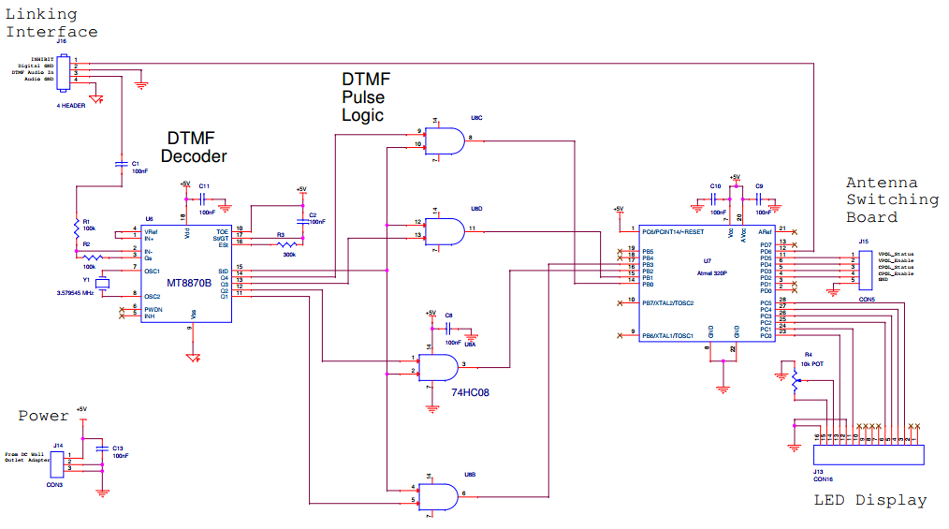

Figure 11: Final DTMF Controller Design

**Design (Software):**

The firmware used for the antenna switching controller is event driven, functioning as a simple state machine. The states are driven via conditions determined by edge triggered interrupt service routines, which originate from signals coming from a MT8870 DTMF decoder chip. Figure 3 (below), shows a high level state diagram on which the firmware is based on. The system also utilizes feedback signals as status bits, in order to be able to read back the current state of either antenna.

All audio coming from the repeater to the linking interface is also sent to the DTMF decoder, however, the embedded system will remain unresponsive until a user keys in a DTMF tone from their transceiver. By default, the program is in the IDLE state, though once a DTMF tone has been detected, the signal from the DTMF chip is detected, causing an interrupt service routine. As a result, the software changes from the IDLE state to the DTMF Detected state, and logs all proceeding incoming tones (as well as the initial tone it detected). If a period of three seconds lapses after, or between tones, a TIMEOUT flag is set, and the program returns the IDLE state, meaning the user must start over.

Once the software has detected a DTMF sequence that is five digits in length, the system changes states to the MSG_DECODE state. At this point, the array of recorded DTMF sequences is checked to see whether it is a match for either of the predetermined sequences for switching the antenna. If no match is found, the system then returns to the IDLE state, while if a match is found, the system will go to either the CPOL_ON state, which is the state used to disable the vertically polarized antenna, and enable the circularly polarized antenna, or to the VPOL_ON state, which is the state used to disable the circularly polarized antenna, and enable the vertically polarized antenna. Upon entering either of those states, first, the software will check to see if the antenna that the user desires to turn on, is already enabled and being utilized by the user. If that is found to be true, the system returns to an IDLE state. Otherwise, the system sends an inhibit signal to the NHRC-2, followed by disabling the antenna currently in use. The disabling of the antenna causes a state change in the feedback signal for that particular antenna, thus causing an interrupt service routine. Upon reading the status bit (feedback signal) from the interrupt service routine, the system is thus assured that the antenna that was previously being used was disabled.

As a result, the system will now enable the antenna that was desired by the user’s DTMF sequence. After the antenna is enabled, the state change in that antennas feedback signal causes another ISR, thus, providing a status bit for the system to check as confirmation that the antenna was successfully enabled. Once the system sees that the antenna was successfully enabled, it then returns back to the IDLE state. A basic state diagram of the software functionality is provided below in Figure 12.

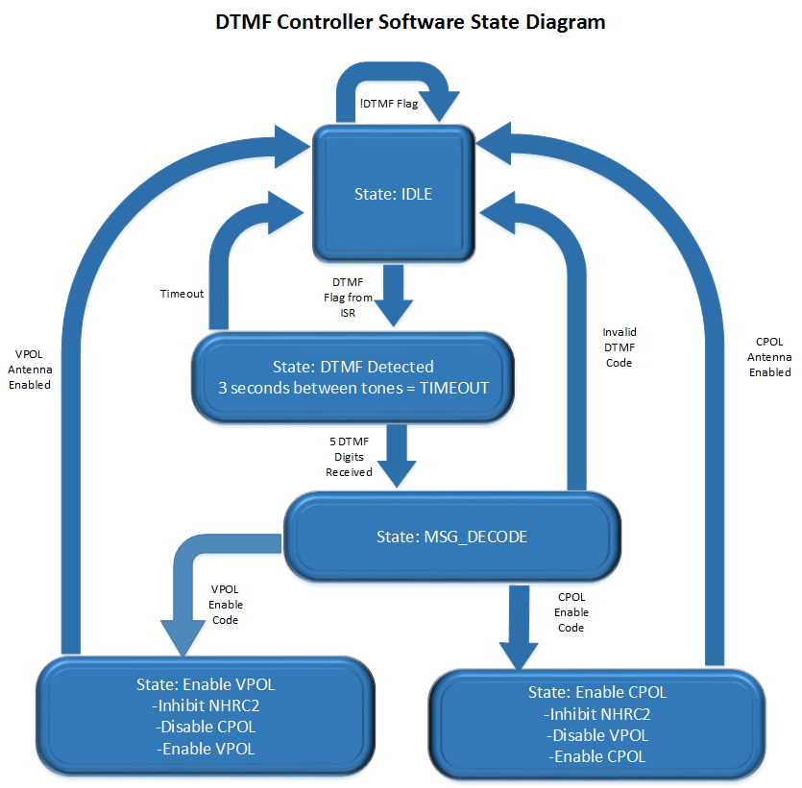

Figure 12: DTMF Software State Diagram

**Design Challenges/Alterations:**

The DTMF controller still needs to be modified to be able to fully function properly. We will remove the pulse logic because that is an asynchronous design and not as stable as just interrupting on the St output low to high. The output is latched, so the MT8870 is actually designed to use St as an interrupt trigger and the decoded output is latched so that the value is not lost.

**Antenna Switching System:**

**Overview:**

In order to evaluate the effectiveness of the circularly polarized antenna versus the linear antenna in real time, a system was required that would allow for rapid switching between the two antennas. This need dictated the creation of an antenna switching system. This system is responsible for regulating the power provided to pair of relays which connect both antennas to the repeater.

**System Requirements:**

The system is required to regulate the power provided to two relays that connect both antennas to the repeater. The state of the system should be dictated by digital logic control signals sent from an independent microcontroller. Feedback should be provided to the microcontroller to indicate the current state of the system.

**Design:**

**Design Overview**

The system controls the operation of the relays through two N-channel enhancement MOSFETs in a low side driver configuration. Rated DC voltage is provided to the relays from the system’s power supply. The operation of each MOSFET is controlled by the application of digital logic level voltages at their gates from an independent microcontroller. The voltage level at the drain of each MOSFET is used as a feedback signal to the microcontroller. Circuitry is included to keep the input to the microcontroller at valid logic levels and also to provide protection to the microcontroller. This system can be divided into four main subsystems: Relays and Transient Protection, Power Supply, MOSFETs and Gate Protection, and Microcontroller Input Circuitry. Each of these four subsystems is explained in greater detail below. Figure 13 below depicts the schematic for this system.

**Relays and Transient Protection**

A 28 Vdc coaxial switch was chosen to switch between the antennas. This switch contains two relays which allows for selection between advancing one input to the output, advancing both inputs to the output, or not advancing any inputs to the output. The 28 Vdc switch was chosen over a similar 120 Vdc coaxial switch because of one distinct feature. The 28 Vdc switch has one relay that is closed when energized, and another relay that is open when energized. This is in opposition to the 120 Vdc switch that contains two relays that are both closed when energized.

We saw this feature as a benefit because if the antenna switching system loses power, it is guaranteed that one antenna will remain connected to the repeater. Not only will this allow for communication in the event that the antenna switching system loses power, but it also offers important protection to repeater. If the repeater attempts to transmit without an antenna connected to it, the power can reflect at the end of the coaxial line and travel back into the repeater, potentially causing damage.

Given that the relays are inductive loads, a form of protection is needed to mitigate the effects of the large voltage transients they will produce when they are switched on or off. To this end, two flyback diodes were incorporated in the design and placed parallel with each of the relays. In the event of such a voltage transient, these diodes essentially allow the relays to draw current from themselves until their energy is dissipated due to resistive losses.

**Power Supply**

In order to provide 28 Vdc to each of the relays, the system requires an input voltage of 120 Vac. This input voltage is fed to a step down transformer which reduces it down to 24 Vac. This is then converted to a DC voltage with the use of a full wave rectifier and smoothing capacitor. The rectification process produces an output voltage of 38 Vdc, which is slightly above the max rated voltage for the relays. To provide rated voltage to the relays, a power resistor is placed in series with each relay, dropping the voltage across them to an acceptable level.

**MOSFETs and Gate Protection**

Two logic level N-channel enhancement MOSFETs were chosen as the means for regulating the power provided to the relays in a low side driver configuration. The logic level N-channel enhancement MOSFETs were an ideal choice for this design because in such a low side driver configuration, they can be fully switched on or off by typical microcontroller output voltages. Two resistors are also connected to the gate of each MOSFET. The first resistor is connected between the gate of the MOSFET and the microcontroller output that will drive it. This resistor acts as a current limiting resistor to protect the gate against overcurrent. The second resistor is connected between the gate and ground. This resistor acts as a pull down resistor and ensures that the gate is always at a valid logic level.

**Microcontroller Input Circuitry**

An important feature of this design is the inclusion of circuitry that will provide feedback to the microcontroller. With the inclusion of this feedback system, the microcontroller will know the state of the antenna switching system. This will mitigate the possibility that the system enters an undesired state. As mentioned previously, it’s essential that one antenna be connected to the repeater when it transmits. Additionally, it is also required that both antennas aren’t connected to the repeater at the same time. If the repeater transmits from both antennas at the same time, the radiation from the two antennas could destructively interfere, significantly degrading the signal quality.

To provide a voltage signal that can be used as an indicator of the current state of a relay, the voltage level at the node between the MOSFET drain pin and the power resistor was chosen. When a relay is energized the voltage at this node will effectively be zero, and will a relay is not energized the voltage at this node will be approximately 38 Vdc. A resistor is placed in between this node and the microcontroller input, to drop the voltage at the input of the microcontroller to approximately 5 Vdc when a relay is not energized.

Two other components are also included at the input to the microcontroller to keep the input pin at valid logic levels. The first is a pull down resistor connected between the input and ground. This is included to pull the input pin down to logic low in the event that something in the circuit becomes disconnected or high-impedance is introduced. A 5.1 Vdc zener diode is also connected between the microcontroller input and ground. The zener diode limits the voltage at the microcontroller input to a maximum of 5.1 volts. Higher voltages at the microcontroller’s input pin could potentially damage the microcontroller.

A resistor and capacitor are also placed at the input to the microcontroller in a configuration that creates a low-pass filter. The advantage of this addition is two fold. First, the resistor in series with the microcontroller input pin acts a current limiting resistor, providing protection against overcurrent. Second, the low pass filter protects the input pin from spurious signals that could potentially cause false readings on the microcontroller.

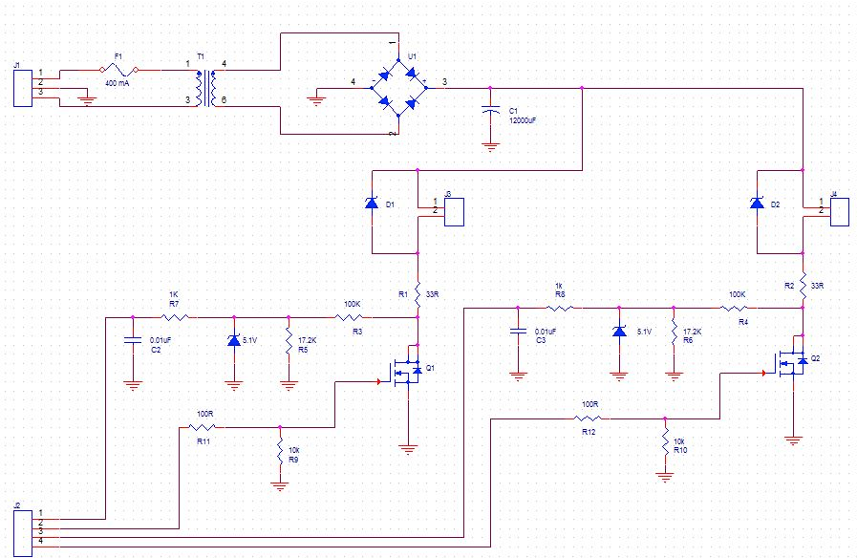

Figure 13: Switching Circuit Schematic

**Linking Interface:**

**Overview:**

The audio linking interface serves as the the central hub for the summing, and distribution of all audio, and control signals to and from the repeater. Due to the system’s necessity of having multiple recipients of the audio signal from the repeater, as well as a need for control logic between these devices, having a single point in the system to facilitate the interaction served as a way to simplify this part of the system.

**Research/System Requirements:**

Each of the RoIP nodes requires two control signals in addition to the audio going in and out. The “push-to-talk” signa (PTT), which goes from the RoIP node to the repeater, serves to tell the repeater when to listen for audio being transmitted from the RoIP node. Similarly, the "carrier-operated-squelch” signal (COS), serves to the the RoIP when to listen for audio coming from the repeater. For the system to function ideally, it must be devised such that at no time can both RoIP nodes transmit audio to the repeater at the same time, thus making the signal inaudible. Therefore, using the digital control signals, control logic must be devised such that the system will abide by the standard at all times.

**Design:**

Within the audio linking interface, there is a two-channel audio summing amplifier for the audio coming from the RoIP nodes, as well as a three-channel audio distribution amplifier for the audio signals going to the antenna switching controller, and the RoIP nodes. The control signals handled within the linking interface include both the PTT, and COS, as well as the inhibit line, which is used to inhibit the NHRC-2 repeater controller, and does not interface with the rest of the control logic present in the design.

A new control signal was devised to serve as a mute control signal for the RoIP nodes. This signal is the result of the embedded logic dealing with the COS and PTT signals. The mute signal functions such that if either device is transmitting, the PTT signal from the transmitting device serves as a control signal to mute the other device from transmitting. In the unlikely event that both RoIP nodes were to transmit at the same time, logic has been devised to give the Echolink node priority over the Allstar Link node to ensure that this cannot happen.

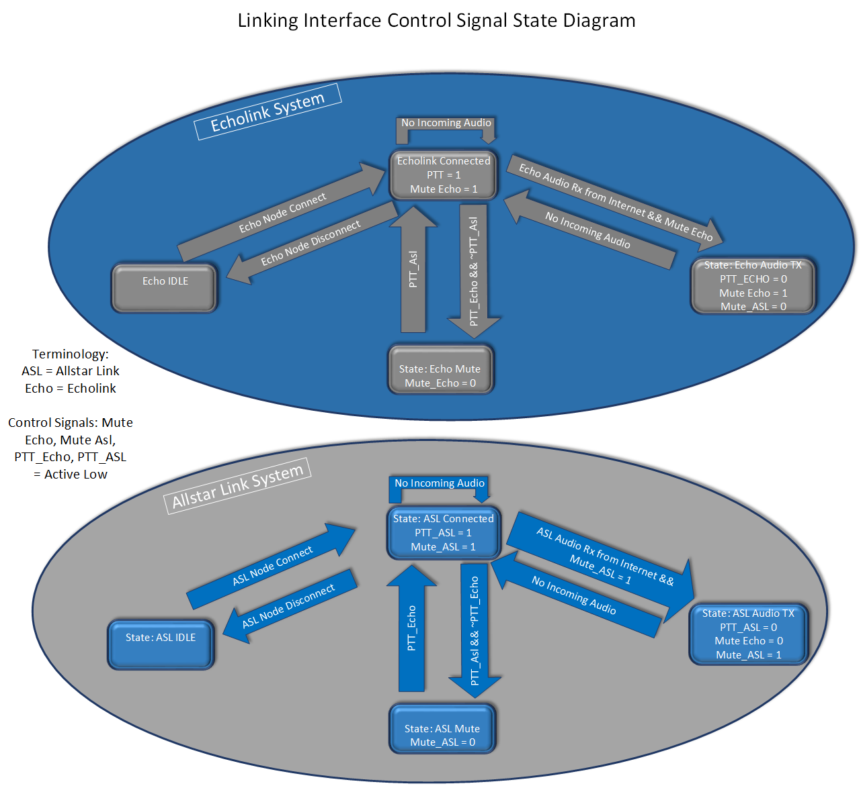

Figure 14: Linking Interface Control Signal State Diagram

**Implementation:**

All audio amplifiers in the design utilize the TL-072 operational amplifier chipset. The TL-072 is well known as a low noise amplifier for audio applications. All logic chips present within the design are from the HC logic family. The first version will be powered using a 9 volt DC wall adapter as a power supply. A voltage divider is used to cut attain a 4.5 volt supply used for the DC offset in the TL-072 amplifiers. Additionally, a 5 volt linear dropout regulator (LDO) is used to attain the 5 volt supply needed to power the HC logic chips. Below, Figure 15 shows the 1st version of the linking interface.

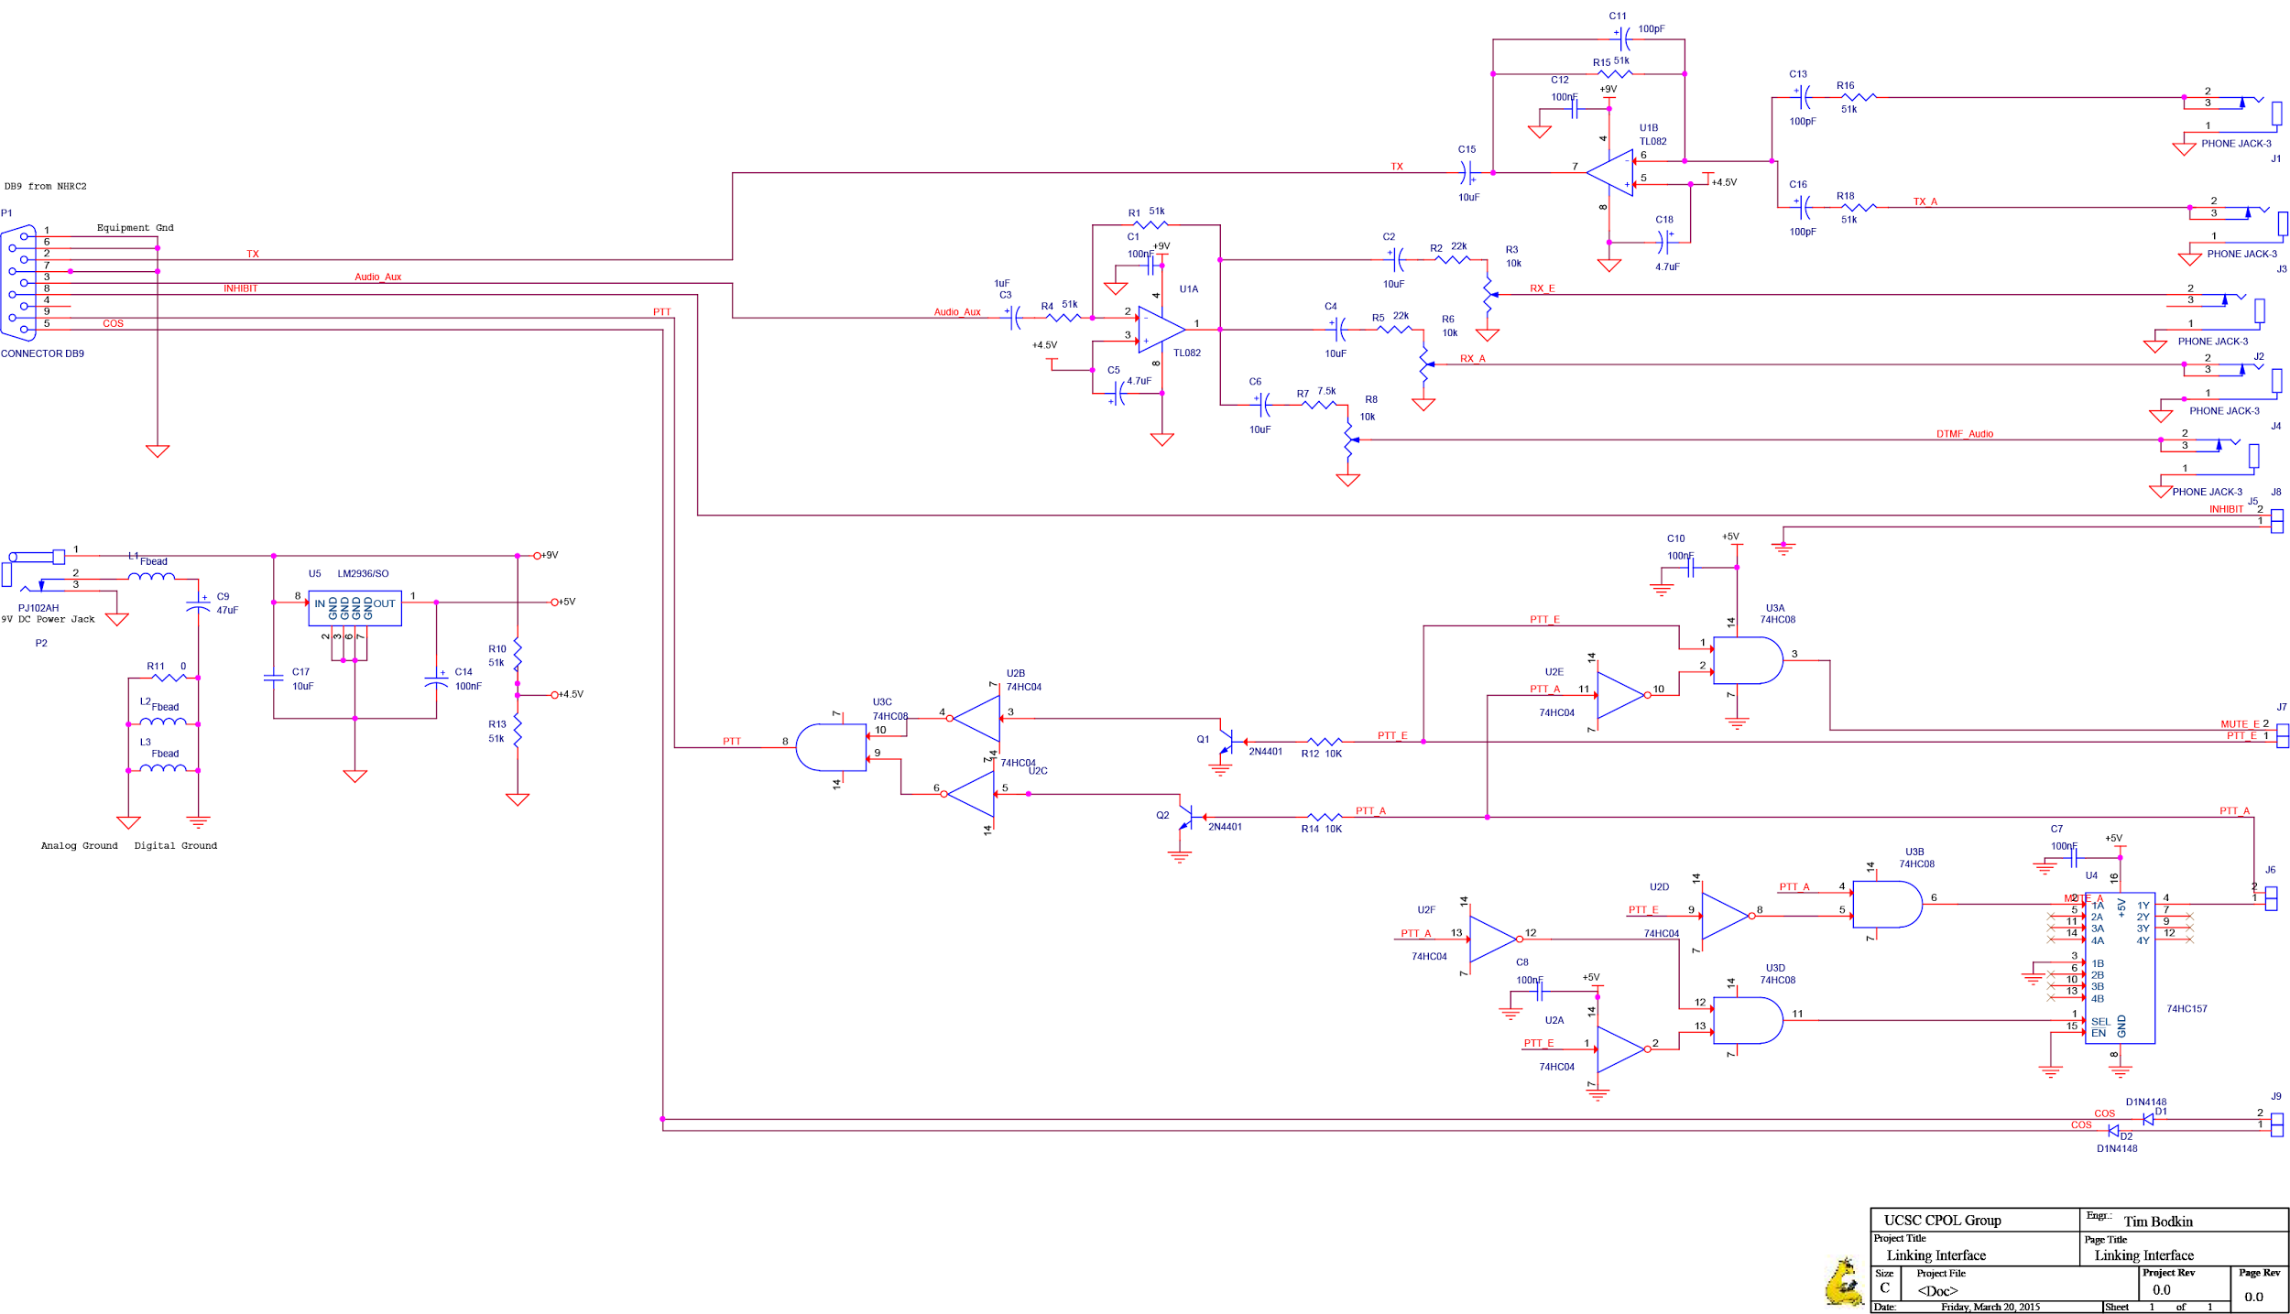

Figure 15: Linking Interface Schematic

**Design Challenges/Alterations:**

Plans for future revisions of this design include the addition of status LEDs, as well as possibly adding potentiometers for volume control at the input of the summing amplifier for the outgoing audio from the RoIP nodes to the repeater. Additionally, the power supply for the design will also be upgraded to utilize the 12-volt DC power supply already being utilized by the repeater system.

**Echolink Node:**

**Overview:**

Echolink offers great versatility in its network, such that users are able to connect to the network using not only transceivers, but also mobile phones, and computers. The Echolink network is reserved exclusively for licensed amateur radio operators only, requiring verification of the user’s FCC issued callsign before they are able to use the network. Once a user is admitted onto the network, they can connect with other Echolink nodes by keying in the desired node number.

**Research/System Requirements:**

Echolink was originally design to work only on windows based machines. However, since its inception, many software packages have been offered, thus offering Echolink software on all platforms (Windows, Linux, and OS X). For this system implementation, the open source software package, SVX-Link was chosen because of its versatile abilities, and features, such as software DTMF decoding, thus not requiring the Echolink node to be connected to a DTMF decoder chip, such as the one present on the antenna switching controller. SVX-Link is a Linux based software package. The Raspberry Pi B+ was chosen as the single board computer to run the Echolink RoIP node. This is partly because of the low cost, as well as the fact that it had been shown to work by the many others that have implemented similar systems using the Raspberry PI.

**Design/Implementation:**

The software runs using a USB audio codec embedded with the C-Media, CM108 chipset. Similarly, this codec was chosen partly because of its low cost, as well as its proven compatibility with the system being designed. Upon Raspberry PI system startup, a shell script runs which configures specific GPIO pins which are used for the PTT, MUTE, and COS control signals for the Echolink software. Next, another shell script runs which sets the audio levels of the audio codec, followed by starting the Echolink software. Assuming all GPIO pins have been correctly setup, the SVX-Link software then starts, and remains in an idle state, listening for DTMF commands from any user.

The SVX-Link software is setup as a series of software modules. To use Echolink, the user must send the DTMF sequence “2-#” to startup the Echolink module. Upon completion of starting the Echolink module, the user is then free to search for a node that they would like to connect with, by means of additional DTMF sequences.

In the next phase of the project, a script will be designed which will handle the mute control signal from the linking interface, thus controlling the disabling of audio playback output from the audio codec.

**Design Challenges/Alterations:**

The SVX-Link software was a simple installation, but configuring the software proved to have a higher learning curve. Once familiarized with the modular design of the software however, configuration proves to be relatively simple, allowing for complete customizability in terms of which ports are used for the control signals..

**Allstar Link Node:**

**Overview:**

The Allstar Link network offers a large user base, and has the ability to establish connections between the two separate networks. This network is also exclusive to licensed amateur radio users, but it allows users to connect to other networks if allowed.

**Research/System Requirements:**

All Star Link uses the Asterisk PBX VOIP as its means of communicating with other nodes. The All Star Link software uses the app_rpt.c module to interface with repeaters. App_Rpt.c is a software module included on older versions of Asterisk that is available in specific OS packages on the All Star Link website. These include Acid, Limey Linux, and the Pickle distribution. Acid, a custom build of CentOS, is meant to run on any hard drive enabled computer system. Limey Linux, on the other hand, is designed for a specific number of single board computers, specifically those with i686 processors and VIA processors. Pickle is the final OS released on the All Star Link website. This specific distribution is made specifically for the BeagleBoard-MX to be used with the DMK engineering LOX board.

**Design:**

Although these distributions are the only ones provided by All Star Link, they are not the only way to install the software on your system. The software has been optimized by these systems, but All Star Link can be installed on virtually any software that can run Asterisk. As long as Asterisk can be installed on a device, All Star Link should be able to install as well because All Star Link uses Asterisk with a custom set of packages and scripts specific to the devices using them. In order to properly install All Star Link on other devices, first the Linux kernel specific to the device, in our case the Odroid-U3 SBC, must be compiled. Some files must be modified to be able to compile; these are specific to external variables used in the creation of the files referencing Limey Linux modules.

**Implementation:**

We decided to implement the All Star Link node using the Odroid U3. In order to run smoothly, All Star Link requires at least 1.2 GHz of processing power, which the Odroid U3 is more than capable of running, at 1.7GHz. The Odroid U3 also comes with a GPIO board that includes the Atmega 328, the same microcontroller we are using for the DTMF controller. By using the Odroid U3 with the GPIO board, we have the possibility of merging the DTMF Controller onto the same board as the All Star Link. The Odroid also uses the same usb audio codec, the CM 108 chipset. This is configured through the chan_usb.c file compiled under Asterisk.

**Design Challenges/Alterations:**

We originally planned to use the IRLP network as a RoIP node. We researched IRLP and planned to make another node using a raspberry pi. We found several schematics online and reverse engineered the board, but we could not get the necessary node number to use IRLP. In the end, IRLP was too restricted and does not allow users to design their own boards. Unfortunately this was several weeks into the project, so we had to find a different network and after researching other amateur radio networks, we decided to implement the All Star Link.

The All Star Link software is fairly easy to install in the provided packages, however, installing the software elsewhere is not intuitive. Firstly, compiling is a long process that takes hours in itself just to complete. The All Star Link software you can download is meant to run under specific distributions released, so when trying to compile them, errors appeared every time compiling started. Editing the configuration files to remove references to Limey Linux and include native modules were the only way to get Asterisk to compile correctly.

**Accomplishments:**

At the close of Winter Quarter, our team has made significant progress towards completing our goals. Some of our notable accomplishments include completed prototypes for the circularly polarized antenna and antenna switching system. Additionally, the Echolink node has been implemented on a Raspberry Pi and is awaiting the completion of the audio linking interface to undergo testing. The DTMF controller prototype PCB has been milled and is ready to be populated. We have also completed the designs for a balun and impedance matching network for use with the circularly polarized antenna. Finally, the audio linking interface design has been completed.

**Future Plans:**

Our early Spring Quarter plans include finishing the remaining prototypes such as the DMTF controller and the audio linking interface, as well as implementing the Allstar Link node. After the DTMF controller prototype is completed and has undergone independent testing, we will begin testing the DTMF controller in conjunction with the antenna switching system. Following the completion of the balun and impedance matching network for the antenna, these three modules will be integrated with the repeater, allowing us to conduct field tests.

To evaluate the signal integrity provided by the circularly polarized antenna our group will conduct field tests in which we go to known areas of poor reception, switch between the two antennas, and measure the improvement (if any). Additionally we will provide the DTMF sequences to ARC members and other local hams so that they may switch the antennas and report their findings.

Concurrently, following the completion of the audio linking interface, we will first test it individually before testing it with other system modules such as the DMTF controller, Echolink node and Allstar Link node. Each phase of testing will be followed by secondary prototypes when necessary. After finalizing our designs, we will integrate our project with the repeater permanently.